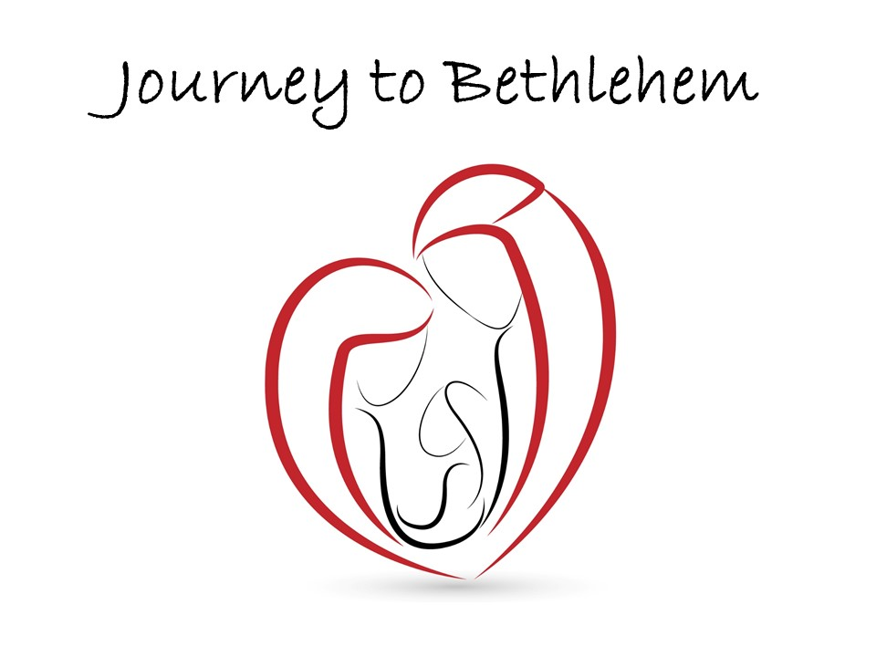

–Worshipping–
Luke 1:39-56

Pastor Kevin Snyder
Coast Hills Community Church
December 20, 2015

“Mary’s Song of the Kingdom: the Gospel before the Gospel”
Luke 1:39-56

What would make you celebrate wildly, without inhibition?

Story behind the Song
Miriam/Mary: Means rebellion or bitter
Hannah: I Samuel 2:1-8

Good News!!
Jesus Comes to Bring a New World Order.
Luke 6:20-23
Lepers, Zacchaeus, Hungry, and Blind
Compare Herod’s Kingdom

How do first world people living relatively wealthy lives view this Good News?
Do you have places of poverty, emptiness, sorrow, insufficiency, brokenness? Wait there… in that place… for Jesus to come.
“If we learn the lesson of Mary's Song we make this revolutionary discovery: Jesus isn't going to meet us in the penthouse of our prosperity, but in the garbage dump of our pain and poverty.” Brian Zahnd

What reasons do you have to celebrate?

