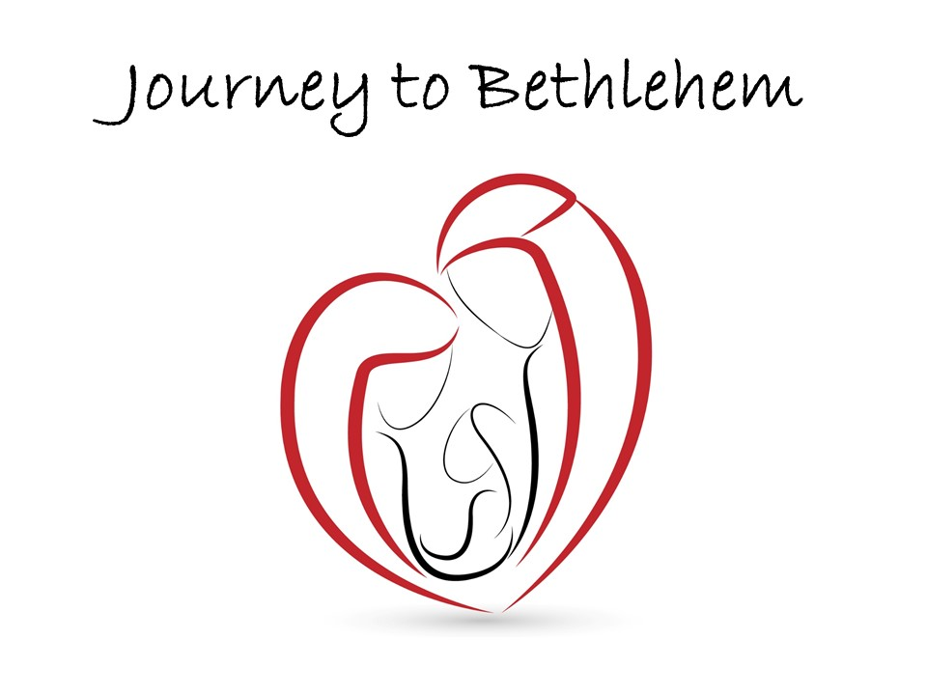

“Gathering”
Luke 1:58–79

Pastor Peter Nikkel
Coast Hills Community Church
December 6, 2015

A Journey to Peace, Fulfillment, and Wholeness!

Luke 1:58-79
The word spread quickly to her (Elizabeth’s) neighbors and relatives of how kind the Lord had been to her (and Zechariah), and everyone rejoiced. 59 When the baby was eight days old, all the relatives and friends came for the circumcision ceremony. They all assumed the baby’s name would be Zacharias, his father. 60 But Elizabeth said, “No! He must be named John!” 61 “What?” they exclaimed. “There is no one in all your family by that name.” 62 So they asked the baby’s father, talking to him by gestures. 63 He motioned for a piece of paper and to everyone’s surprise wrote, “His name is John!” 64 Instantly Zacharias could speak again, and he began praising God. 65 Wonder fell upon the whole neighborhood, and the news of what had happened spread through the Judean hills. 66 And everyone who heard about it thought long thoughts and asked, “I wonder what this child will turn out to be? For the hand of the Lord is surely upon him in some special way.”

67 Then his father, Zacharias, was filled with the Holy Spirit and gave this prophecy: 68 “Praise the Lord, the God of Israel, for he has come to visit his people and has redeemed them. 69 He is sending us a Mighty Savior from the royal line of his servant David, 70 just as he promised through his holy prophets long ago— 71 someone to save us from our enemies, from all who hate us. 72-73 “He has been merciful to our ancestors, yes, to Abraham himself, by remembering his sacred promise to him, 74 and by granting us the privilege of serving God fearlessly, freed from our enemies, 75 and by making us holy and acceptable, ready to stand in his presence forever. 76 “And you, my little son, shall be called the prophet of the glorious God, for you will prepare the way for the Messiah. 77 You will tell his people how to find salvation through forgiveness of their sins. 78 All this will be because the mercy of our God is very tender, and heaven’s dawn is about to break upon us, 79 to give light to those who sit in darkness and death’s shadow, and to guide us to the path of peace.”

Luke 2:52
“So Jesus grew both in height and in wisdom, and he was loved by God and by all who knew him.”

Key: Bethlehem in our title is a metaphor. Bethlehem stands for Jesus. We are making a faith journey wanting to get closer to Jesus.

- Jesus is the way to peace.

Luke 1:78
All this will be because the mercy of our God is very tender, and heaven’s dawn is about to break upon us, 79 to give light to those who sit in darkness and death’s shadow, and to guide us to the path of peace.”

Philippians 4:7
7 Then you will experience God’s peace, which exceeds anything we can understand. His peace will guard your hearts and minds as you live in Christ Jesus.

- Jesus is the way to fulfilling engagement.

In Hebrew ‘Bethlehem’ means ‘house of bread’ and in Arabic ‘Bethlehem’ means ‘house of meat’.

Luke 1:76
“And you, my little son, shall be called the prophet of the glorious God, for you will prepare the way for the Messiah.

Luke 19:10
10 For the Son of Man came to seek and save those who are lost.”

John 10:10
10 The thief’s purpose is to steal and kill and destroy. My purpose is to give them a rich and satisfying life.

Ephesians 2:10
10 “For we are God’s masterpiece. He has created us anew in Christ Jesus, so we can do the good things he planned for us long ago.”

Ephesians 6:7
7 Work with enthusiasm, as though you were working for the Lord rather than for people.

- Jesus is the way to restoring shattered dreams.

Luke 1:76
“And you, my little son, shall be called the prophet of the glorious God, for you will prepare the way for the Messiah. 77 You will tell his people how to find salvation through forgiveness of their sins. 78 All this will be because the mercy of our God is very tender, and heaven’s dawn is about to break upon us,”

Luke 4:18-19
18 “The Spirit of the Lord is upon me, for he has anointed me to bring Good News to the poor. He has sent me to proclaim that captives will be released, that the blind will see that the oppressed will be set free,
19 and that the time of the Lord’s favor has come.”

Matt 11:28
Then Jesus said, “Come to me, all of you who are weary and carry heavy burdens, and I will give you rest. 29 Take my yoke upon you. Let me teach you, because I am humble and gentle at heart, and you will find rest for your souls. 30 For my yoke is easy to bear, and the burden I give you is light.”

That’s the meaning of Christmas. That’s why we’re going to Bethlehem.

