“Finding Faith: Part 3 – Faith AND Doubt”
Matthew 28:17

Pastor Kevin Snyder
Coast Hills Community Church
November 22, 2015

Matthew 28:17
“When they saw Him, they worshiped Him, but some doubted.”

Quotes:
“A faith without some doubts is like a human body with no antibodies in it. People who blithely go through life too busy or indifferent to ask the hard questions about why they believe as they do will find themselves defenseless against either the experience of tragedy or the probing questions of a smart skeptic. A person's faith can collapse almost overnight if she failed over the years to listen patiently to her own doubts, which should only be discarded after long reflection. Believers should acknowledge and wrestle with doubts—not only their own, but their friends' and neighbors.” – Timothy Keller, Reason for God.
“Don’t play the game of feeding doubt reasons for your faith. You don’t have to justify your faith to doubt. If you have to doubt something…doubt your doubts. Don’t’ give doubt a free pass. Make doubt doubt its assertions. Make doubt feed on itself.” – Brian Zahnd
“Doubt isn't the opposite of faith; it is an element of faith.” ― Paul Tillich

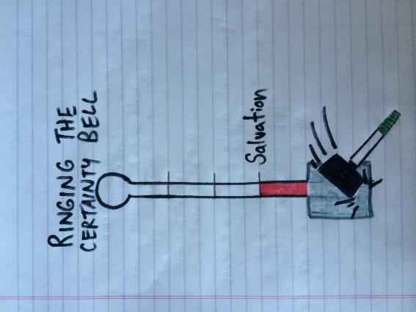
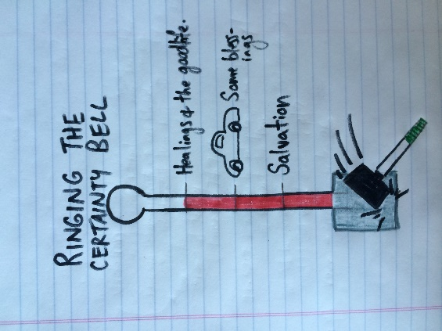
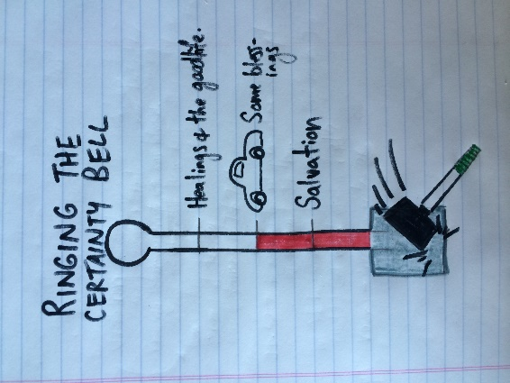
Ringing the Certainty Bell
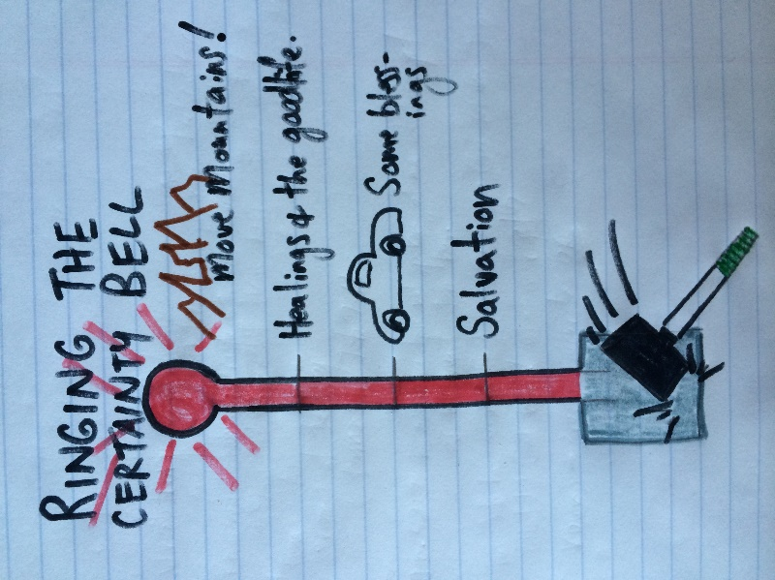
Story of a Faith Healer

Wrestling with God gets you a belt and a new name!
Jacob renamed
Genesis 32:22-30

Ugly Honesty
Job 7:11
I cannot keep from speaking. I must express my anguish. My bitter soul must complain.
Job 42:7
After the Lord had finished speaking to Job, he said to Eliphaz the Temanite: “I am angry with you and your two friends, for you have not spoken accurately about me, as my servant Job has.

Worship AND Doubt
Matthew 28:17
“When they saw Him, they worshiped Him, but some doubted.”
In the midst of the doubt, the desperation and the despair, when faith seems faint and small, there God is with us and for us.

