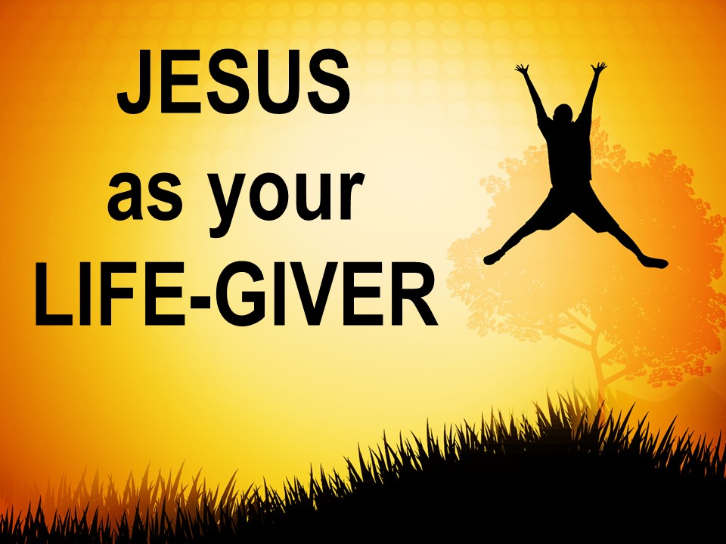

“A Blessing: May You Know Jesus as Your Life-Giver”

John 10:10

Pastor Wayne Driedger
Coast Hills Community Church
September 13, 2015

John 10:10 “The thief’s purpose is to steal and kill and destroy. My purpose is to give them a rich and satisfying life.” - Jesus

John 6:35 Jesus replied, “I am the bread of life. Whoever comes to me will never be hungry again. Whoever believes in me will never be thirsty.”

John 6:53-54 So Jesus said again, “I tell you the truth, unless you eat the flesh of the Son of Man and drink his blood, you cannot have eternal life within you. ⁵⁴ But anyone who eats my flesh and drinks my blood has eternal life, and I will raise that person at the last day.”

John 6:68 Simon Peter replied, “Lord, to whom would we go? You have the words that give eternal life.”

John 7:37-38 On the last day, the climax of the festival, Jesus stood and shouted to the crowds, “Anyone who is thirsty may come to me! ³⁸ Anyone who believes in me may come and drink! For the Scriptures declare, ‘Rivers of living water will flow from his heart.’”

John 8:12 Jesus spoke to the people once more and said, “I am the light of the world. If you follow me, you won’t have to walk in darkness, because you will have the light that leads to life.”

