2015 – The Year of Flourishing

Coast Hills Community Church
May 31, 2015
Pastor Wayne Driedger

Then Jesus said, “What is the Kingdom of God like? How can I illustrate it?¹⁹ It is like a tiny mustard seed that a man planted in a garden; it grows and becomes a tree, and the birds make nests in its branches.”
Luke 13:18-19
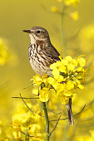

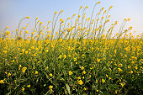

- A church that flourishes makes connecting to Jesus the first priority.

- A church that flourishes is where every person participates – every member has a mission

- A church that flourishes is a place that celebrates

