Always Hungry and Thirsty
Matthew 5:6; John 7:37-39
Paul Wartman

Benson in the ‘diviners’ hut

Lining up for baptism
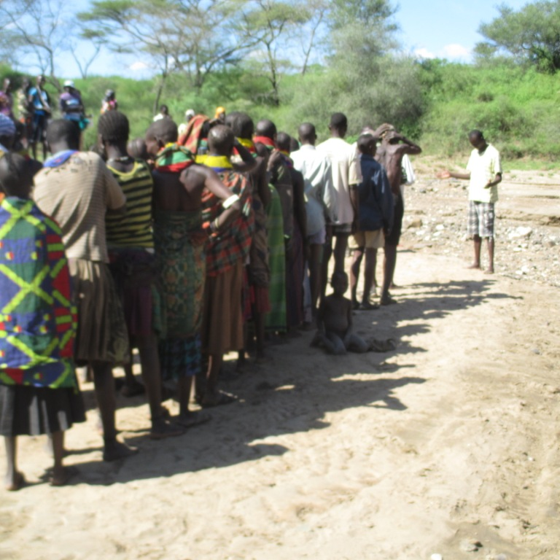

One water source
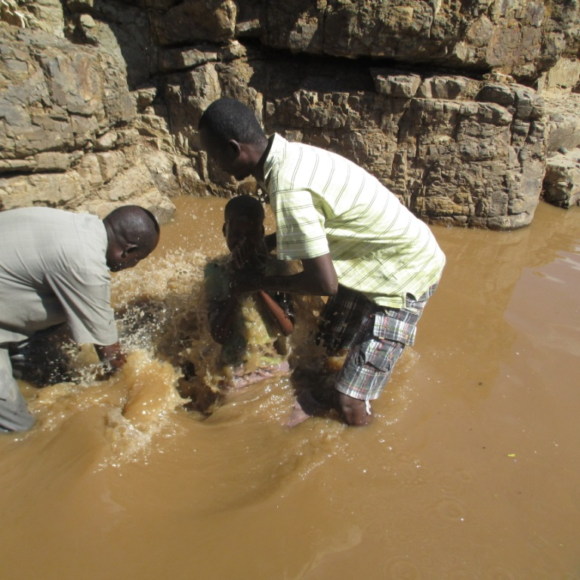

Digging a grave
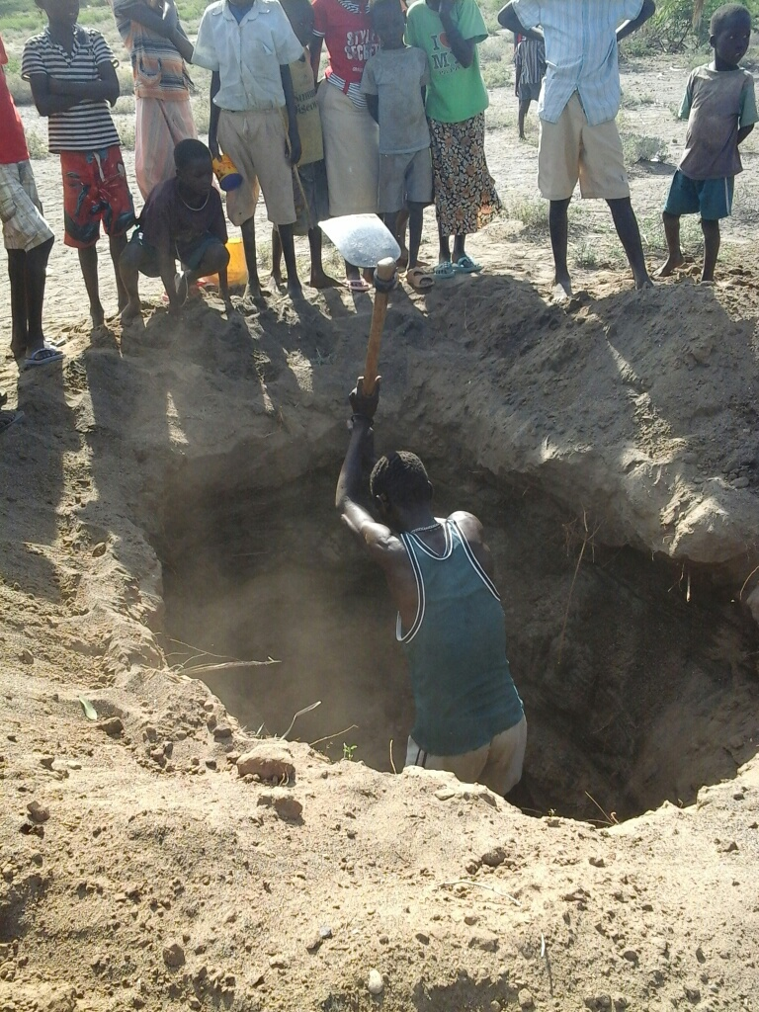

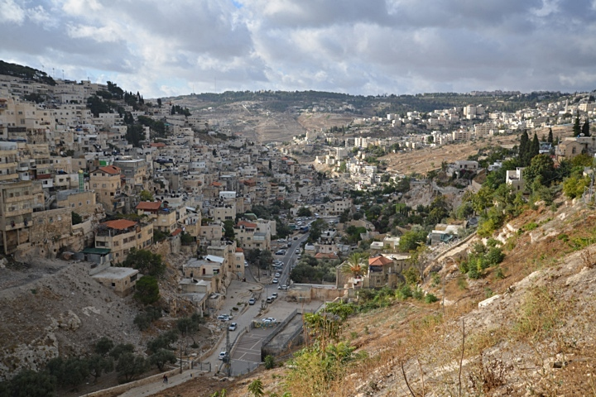

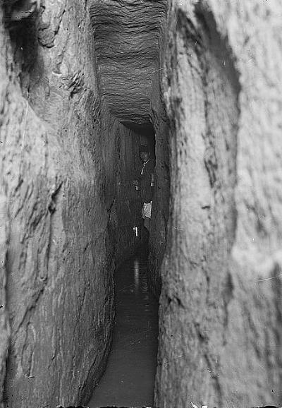

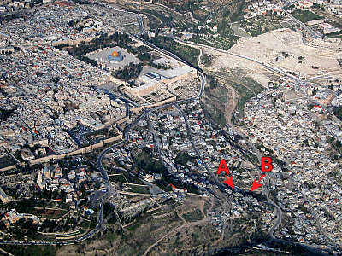

Hungry and Thirsty
- John 7:1-10 (NIV)
- Matthew 5:6 (NIV)
- John 7:37-39 (NIV)

- Who receives the Spirit’s fullness?
- those who are thirsty

- Jeremiah 2:13 My people have committed two sins: They have forsaken me, the spring of living water, and have dug their own cisterns, broken cisterns that cannot hold water.

- How do we receive the Spirit’s fullness?
- there is no formula, but there is a pattern

- four action verbs:
    - thirst
    - come
    - drink
    - believe

- What are the results of the Spirit’s fullness?
- not specific spiritual gifts, but specific spiritual fruit

- from ‘rivers of living water’

