Harold Ekkert – CHCC – July 27, 2014
Blessed are the pure in heart for they will see God (Mt 5:8)
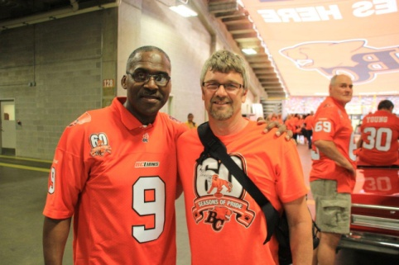

- Blessed

- Pure heart

Psalm 24:3-6 New International Version (NIV)

3 Who may ascend the mountain of the Lord?
Who may stand in his holy place?
4 The one who has clean hands and a pure heart,
who does not trust in an idol
or swear by a false god.

5 They will receive blessing from the Lord
and vindication from God their Savior.
6 Such is the generation of those who seek him,
who seek your face, God of Jacob.

Mark 7:20-23 New International Version (NIV)
²⁰ He went on: “What comes out of a person is what defiles them. ²¹ For it is from within, out of a person’s heart, that evil thoughts come—sexual immorality, theft, murder, ²² adultery, greed, malice, deceit, lewdness, envy, slander, arrogance and folly.²³ All these evils come from inside and defile a person.”

Psalm 51:10 New International Version (NIV)
¹⁰ Create in me a pure heart, O God,
and renew a steadfast spirit within me.
- See God

1 Corinthians 13:12 New International Version (NIV)
¹² For now we see only a reflection as in a mirror; then we shall see face to face. Now I know in part; then I shall know fully, even as I am fully known.

John 14:4-10, 19-23 New International Version (NIV)
⁴ You know the way to the place where I am going.”
⁵ Thomas said to him, “Lord, we don’t know where you are going, so how can we know the way?”
⁶ Jesus answered, “I am the way and the truth and the life. No one comes to the Father except through me. ⁷ If you really know me, you will know^{[a]} my Father as well. From now on, you do know him and have seen him.”
⁸ Philip said, “Lord, show us the Father and that will be enough for us.”
⁹ Jesus answered: “Don’t you know me, Philip, even after I have been among you such a long time? Anyone who has seen me has seen the Father. How can you say, ‘Show us the Father’? ¹⁰ Don’t you believe that I am in the Father, and that the Father is in me? The words I say to you I do not speak on my own authority. Rather, it is the Father, living in me, who is doing his work.
¹⁹ Before long, the world will not see me anymore, but you will see me. Because I live, you also will live. ²⁰ On that day you will realize that I am in my Father, and you are in me, and I am in you. ²¹ Whoever has my commands and keeps them is the one who loves me. The one who loves me will be loved by my Father, and I too will love them and show myself to them.”
²² Then Judas (not Judas Iscariot) said, “But, Lord, why do you intend to show yourself to us and not to the world?”
²³ Jesus replied, “Anyone who loves me will obey my teaching. My Father will love them, and we will come to them and make our home with them.

1 John 3:1-3 New International Version (NIV)
1 See what great love the Father has lavished on us, that we should be called children of God! And that is what we are! The reason the world does not know us is that it did not know him. ² Dear friends, now we are children of God, and what we will be has not yet been made known. But we know that when Christ appears, we shall be like him, for we shall see him as he is. ³ All who have this hope in him purify themselves, just as he is pure.

