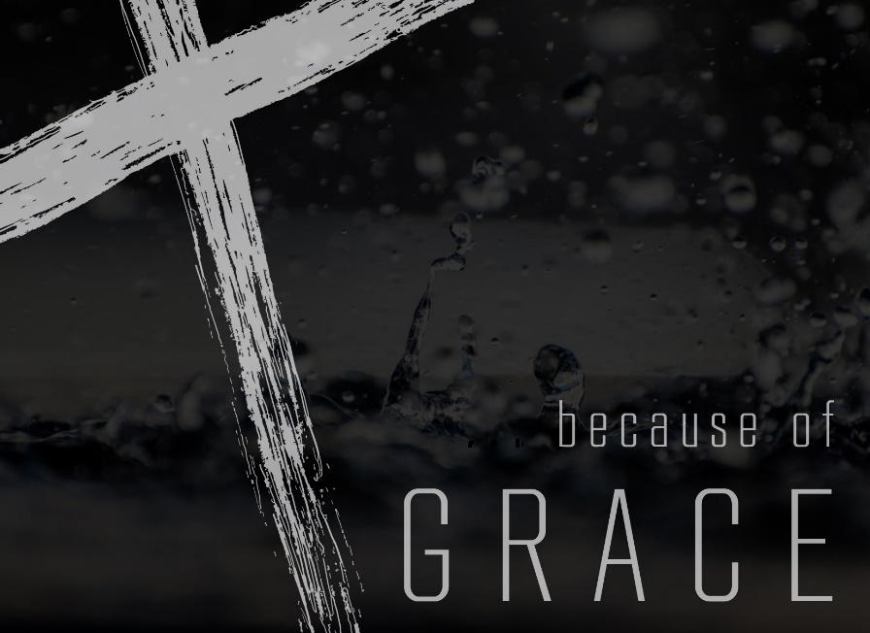
Pastor Wayne Driedger
Coast Hills Community Church
February 1, 2015

Ephesians 1:1-2
This letter is from Paul, chosen by the will of God to be an apostle of Christ Jesus. I am writing to God’s holy people in Ephesus, who are faithful followers of Christ Jesus. ² May God our Father and the Lord Jesus Christ give you grace and peace.

Intro: Checking out a letter written from Paul to people in Ephesus.
Should we be reading a letter written to some other people?
Illust: Wally’s mail box being bust into.
Map of Paul’s 2nd? Missionary Journey
Circles around and came back to the original church Jerusalem.
Picture of Ephesus – nice place to visit. Cruise ships go there and you go to the ruins of Ephesus – temple of Artemis. One of the 7 great ancient wonders.
Artemis was the goddess of fertility.
Picture of 24,000 seat theatre
4th largest city in the roman world – 300-500,000 people
When I went to Caesarea – wow – this is impressive. This is meant to overwhelm you with the power of Rome. Caesar is Lord. Rome is boss!
Picture of the Temple of Artemis
Idols and incantations were fine as long as you worship Caesar. Keep them happy.
This letter is from Paul, chosen by the will of God to be an apostle of Christ Jesus.
I am writing to God’s holy people in Ephesus, who are faithful followers of Christ Jesus.
² May God our Father and the Lord Jesus Christ give you grace and peace.

Acts 18 and 19 The Holy Spirit is what sets us apart from every other religion. You got to understand the Holy Spirit. We will talk about that in the coming days.
Always Priscilla and Aquilla….always the woman written before the man. In a patriarchal society, the woman is given the leadership in the relationship. Interesting….already this was busting cultural stereotypes.
Paul gets set up to talk for 2 years in the lecture hall. Travellers would come and check out the theatre and then go down to the lecture hall and hear Paul with their little idols.
Idols do something that is all about what you do for the gods….Grace is something completely different.
We don’t do some kind of incantations. This not about rituals. This is about living every day in relationship with God.
This is not now white magic.
Everybody that was trying to tap into powers. This is about God’s power.
He invites us to LORD GOD. Not a genie
This is gracious God.
Vs. 2 You are holy people because of what God has done. You follow Jesus because of Grace
Acts 19:13-23 Followers were those who came and burned their incantation books. When they saw the power of Jesus they confessed their evil practices
An idol you give just a little time to, a bit of teaching……different than being a follower.
Magic genie God serves me.
Cosmic Consultant God works for me.
Saw the power of Jesus and now they knew they needed to lay down.
Lord God – I serve him. I take the verses I don’t like and I really pay attention to them because I need to.
It will put a dent in everything I have. It will change everything. The power of the name of Jesus.
The guy in the lecture hall is messing with our business. They had power and Ephesus was changed. Because of the power of the people….not the number of people but the power of Jesus in the people.
This was not written to individuals but to a whole church. It would be sent to a whole bunch of churches. He wrote no names in Ephesians…a place he spent more time than anywhere.
Wrote about a lot of issues….some of them…Family can be tough – he gives instructions on that
Do I trust God with my eternity or my daily life? How do I deal on each day and with each person? City is impacted and rocked to the core.
I am all in.
Wages of sin – that is the price. You took your life from God. He sees us as saints. Grace. He asks for all of us in return…..that is lordship.
Grace – it calls something from us. Power. I give you all the days of my life.
⁴ But God is so rich in mercy, and he loved us so much, ⁵ that even though we were dead because of our sins, he gave us life when he raised Christ from the dead. (It is only by God’s grace that you have been saved!) Ephesians 2:4-5
When we lay down our lives we find life.
Paul spoke about GRACE
Grace is a Free Gift
You gave your life. It cost you. Maximillian Kolby
Grace is Free
It cannot be earned.
Forgiveness, peace, meaning all of these things we receive freely.
Now I am free to love others.
I gotta sit and think about that for a while. You mean I was as good as dead and now I am alive. Let me think about that.
Grace is unmerited favour
Grace is Life
It’s the difference of life and death.
It doesn’t suck the life out of you. Every religious practice has a way of sucking the life out of you. It may not feel that way because there is something good and noble about doing the right and good thing. But in the end, it is about you and it’s about me and I gotta get what goes around. Someone will have to pay it forward to me. That will leave you dead.
If I do this, then God will do this for me. That is life sucking. You are always in a position of pleading and wishing and hoping.
Because of Grace….
Baptism. Initiation into both biblical worshiping communities began with a disabling act. Only after we have been laid low are we able to rise.
The sacraments of the church are rehearsals of the end of power, putting our own power to death in baptism and then approaching with trembling awe the memorial of the moment when God’s own Son gave up his power.
There are many everyday responses to grace. Kindness, thankfulness, telling others where to find grace, listening, sacrifice, surrender.
Baptism and Communion are re-enactments of God’s grace
They are appropriate responses to grace. Because of Grace…

