The HEART of Friendship:
David & Jonathan and the Friendship of God.
1 Samuel 18-20
LIFE group Questions.
Sept. 28, 2014

- If you haven’t already, read chapters 18 – 20 of 1 Samuel. What are some key images of Jonathan and David’s friendship that stands out to you?

- Chapter 18:1-7 explains how everybody “loved” David in different ways: Discuss how differently Saul, Jonathan, the Israel Army, and the women of Israel “loved” David?

- Discuss what covenantal friendship is, what it looks like and how it would start?

- Do you have a friend like Jonathan? If so, explain what that friendship looks like.

- Tim Keller is quoted saying, “Love is the effort and desire to make someone else everything they were created to be.” How can we do that in an age where individualism is so dominant in our culture?

- We’re criticized, teased, avoided, attacked, shot at, abandoned, cursed, hunted down, snubbed, stabbed in the back, treated like a doormat, damned with faint praise. Not all of those things, and not all the time, but enough of them and often enough to realize that not everyone shares God’s excellent attitude toward us.––EUGENE PETERSON Have you ever felt like that? Do you know others that have felt this way? How do we show value and worth to people even if they are not our good friends? What would that look like?

- Discuss Jesus’ statement, “there is no greater love than to lay down one’s life for one’s friends” – John 15:13. So what does that mean for me and in my own life and how I treat others?

- Take time to look at and reflect on the Friendship Icon on the next page. What do you see? How might this reflect your relationship with Jesus as you follow him?

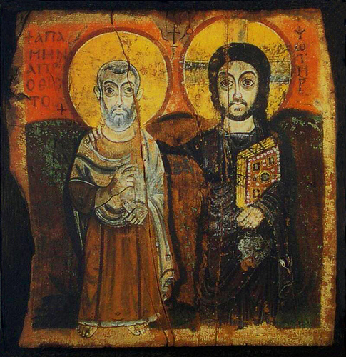

The Icon of Friendship

The original was s discovered in 1902 after lying hidden in the ruins of the monastery of Bawit for many centuries. It is now preserved in the Musée du Louvre, Paris.

"This unique icon, dating from the seventh century, is not from the Byzantine tradition like the icons of Greece and Russia, but from the Coptic Church of Egypt. It is painted in the clear and naïve-seeming Coptic style. It shows Christ and an early Egyptian saint called Menas – the names are written in Coptic letters near the top of the icon. But Menas can be seen as standing for every believer: the icon tells something about the friendship that Christ offers to everyone who will accept it. This is why Brother Roger particularly liked this icon, and why it holds a special place at Taizé. Christ has his arm on his friend’s shoulder, as a sign of his love. The initiative in this gesture is with Christ: 'This is love,' says St. John, 'not that we loved God, but that he loved us' (1 John 4:10). Receiving this love of Christ, his friend is able with his right hand to bless others. This is one of the essential movements of the Gospel: letting ourselves be loved by God leads naturally and simply to transmitting a blessing to other people. love between Christ and the believer is not a closed circle: it opens out more and more widely. This is also reflected in the position of the two figures: they are not sitting looking at each other, but they are walking forward in the same direction. Christ, as we have seen before, carries the book of the Word of God. The believer carries a small scroll – a suggestion, perhaps, that Christ alone understands the fullness of God’s wisdom, but that the very little we understand is enough to enable us to go forward with him." _ Brother Jean-Marc of the Taize commounity

